**The Center for Career Services Team**



**Josh Alejandra Cyndi Assistant Director Career Services Director Associate Director**



**Nicole Anja Kelly   
 Career Counselor Administrative Employer Relations   
 Assistant Coordinator**

**Come meet with one of our amazing career advisors for all your career needs!**

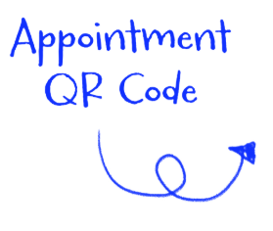 **We look forward to seeing you soon!**